**YEAR 12 CHEMISTRY - ATCHE**

**TASK 8: PRACTICAL ASSESSMENT 2021**

**Identifying Unknown Organic Compounds**

**Recommended time: 60 minutes**

**Total marks**

**/20**

**Suggested:**

* *Planning: 20 minutes*
* *Experimentation: 40 minutes*

Name: \_\_\_\_\_\_\_\_\_\_\_\_\_\_\_\_\_\_\_\_\_\_\_\_\_\_\_\_\_\_\_\_\_\_\_\_\_\_\_\_\_

Teacher: \_\_\_\_\_\_\_\_\_\_\_\_\_\_\_\_\_\_\_\_\_\_\_\_\_\_\_\_\_\_\_\_\_\_\_\_\_\_\_\_\_

Introduction:

The identification and characterization of the structures of unknown substances are an important part of organic chemistry.

In this experiment you will carry out several **qualitative** tests that will allow you to identify functional groups in unknown organic substances. You will apply what you have learned by characterizing the unknown organic compounds in terms of their chemical reactions.

**AIM:**

The purpose of this investigation is to identify a set of unknown liquids. It will be necessary for you to plan

a series of **physical** and/or **chemical tests** to identify the unknowns provided and carry out the procedure.

You will be given SMALL liquid samples of

**cyclohexene, ethanol, ethanoic acid and cyclohexane**

each randomly labeled as A, B, C, and D. You will also be provided with common laboratory reagents including distilled water, bromine water (Br2 (aq)), marble chips (CaCO3), potassium permanganate (KMnO4) solution and concentrated sulfuric acid.

**../../../../../../Pictures/SnapNDrag%20Library.snapndraglibrary/c2f459378/pic_**

****

****

**Instructions:**

1) Work out suitable experimental procedures to identify the substances.

**Important note:**

1. Use very small amounts of the lab reagents (e.g. 1 mL) in any chemical reaction to enable them to be the limiting reactant.
2. Reagents available are: **distilled water, bromine water (Br2 (aq)), marble chips (CaCO3), potassium permanganate solution (KMnO4) and concentrated sulfuric acid.**
3. Plan to do the ‘simple’ tests to the maximum number of unknowns, leaving the more complex tests to fewer numbers of unknowns to save time.
4. You cannot use acid-base indicators or ester formation as one of your tests.
5. **If you work out the last chemical by elimination, conduct a chemical test to ensure its identity is correct**.

2) Construct a flow chart in the **Procedure** section similar to the one illustrated below, to show your sequence of experimentation.

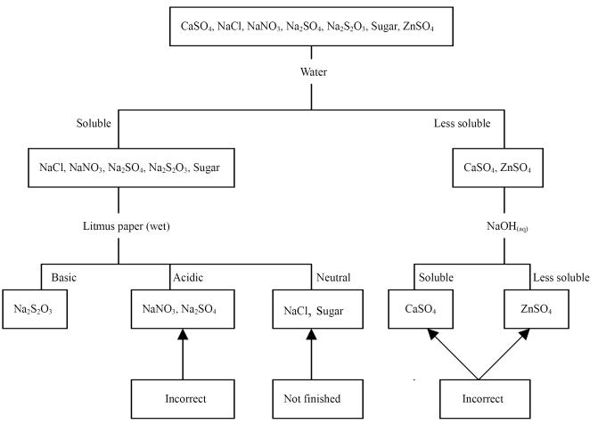

**PROCEDURE:**

**Sequential flow chart (or dichotomous key): [2 marks]**

**A B C D**

1. **(a) BRIEFLY describe all tests to be performed in the same sequence as your flow chart, noting how the result would identify the unknown: [4 marks]**

|  |
| --- |
|  |
|  |
|  |
|  |
|  |
|  |
|  |
|  |
|  |
|  |
|  |
|  |
|  |
|  |
|  |
|  |
|  |

**(b) State two safety considerations which you need to make when conducting your experiments.**

**[2 marks]**

\_\_\_\_\_\_\_\_\_\_\_\_\_\_\_\_\_\_\_\_\_\_\_\_\_\_\_\_\_\_\_\_\_\_\_\_\_\_\_\_\_\_\_\_\_\_\_\_\_\_\_\_\_\_\_\_\_\_\_\_\_\_\_\_\_\_\_\_\_\_\_\_\_\_\_\_\_\_\_\_\_\_\_\_\_

\_\_\_\_\_\_\_\_\_\_\_\_\_\_\_\_\_\_\_\_\_\_\_\_\_\_\_\_\_\_\_\_\_\_\_\_\_\_\_\_\_\_\_\_\_\_\_\_\_\_\_\_\_\_\_\_\_\_\_\_\_\_\_\_\_\_\_\_\_\_\_\_\_\_\_\_\_\_\_\_\_\_\_\_\_

\_\_\_\_\_\_\_\_\_\_\_\_\_\_\_\_\_\_\_\_\_\_\_\_\_\_\_\_\_\_\_\_\_\_\_\_\_\_\_\_\_\_\_\_\_\_\_\_\_\_\_\_\_\_\_\_\_\_\_\_\_\_\_\_\_\_\_\_\_\_\_\_\_\_\_\_\_\_\_\_\_\_\_\_\_

IN YOUR RESULTS FOLLOWING:

State all observations.

Write suitable chemical equations where possible to support your observations

Identify and state the chemical name of the unknowns.

**RESULTS [12 marks]**

**Unknown sample A**

|  |  |
| --- | --- |
| **1st Test** performed |  |
| **Observation** (write **nvr** if no change occurs) |  |
| **Inference** (include a chemical equation where possible) |  |

If required

|  |  |
| --- | --- |
| **2nd Test** performed |  |
| **Observation** (write **nvr** if no change occurs) |  |
| **Inference** (include a chemical equation where possible) |  |

|  |  |
| --- | --- |
| **3rd Test** performed |  |
| **Observation** (write **nvr** if no change occurs) |  |
| **Inference** (include a chemical equation where possible) |  |

|  |  |
| --- | --- |
| **4th Test** performed |  |
| **Observation** (write **nvr** if no change occurs) |  |
| **Inference** (include a chemical equation where possible) |  |

|  |
| --- |
| Conclusion:  Unknown sample A is |

**Unknown sample B**

|  |  |
| --- | --- |
| **1st Test** performed |  |
| **Observation** (write **nvr** if no change occurs) |  |
| **Inference** (include a chemical equation where possible) |  |

If required

|  |  |
| --- | --- |
| **2nd Test** performed |  |
| **Observation** (write **nvr** if no change occurs) |  |
| **Inference** (include a chemical equation where possible) |  |

|  |  |
| --- | --- |
| **3rd Test** performed |  |
| **Observation** (write **nvr** if no change occurs) |  |
| **Inference** (include a chemical equation where possible) |  |

|  |  |
| --- | --- |
| **4th Test** performed |  |
| **Observation** (write **nvr** if no change occurs) |  |
| **Inference** (include a chemical equation where possible) |  |

|  |
| --- |
| Conclusion:  Unknown sample B is |

**Unknown sample C**

|  |  |
| --- | --- |
| **1st Test** performed |  |
| **Observation** (write **nvr** if no change occurs) |  |
| **Inference** (include a chemical equation where possible) |  |

If required

|  |  |
| --- | --- |
| **2nd Test** performed |  |
| **Observation** (write **nvr** if no change occurs) |  |
| **Inference** (include a chemical equation where possible) |  |

|  |  |
| --- | --- |
| **3rd Test** performed |  |
| **Observation** (write **nvr** if no change occurs) |  |
| **Inference** (include a chemical equation where possible) |  |

|  |  |
| --- | --- |
| **4th Test** performed |  |
| **Observation** (write **nvr** if no change occurs) |  |
| **Inference** (include a chemical equation where possible) |  |

|  |
| --- |
| Conclusion:  Unknown sample C is |

**Unknown sample D**

|  |  |
| --- | --- |
| **1st Test** performed |  |
| **Observation** (write **nvr** if no change occurs) |  |
| **Inference** (include a chemical equation where possible) |  |

If required

|  |  |
| --- | --- |
| **2nd Test** performed |  |
| **Observation** (write **nvr** if no change occurs) |  |
| **Inference** (include a chemical equation where possible) |  |

|  |  |
| --- | --- |
| **3rd Test** performed |  |
| **Observation** (write **nvr** if no change occurs) |  |
| **Inference** (include a chemical equation where possible) |  |

|  |  |
| --- | --- |
| **4th Test** performed |  |
| **Observation** (write **nvr** if no change occurs) |  |
| **Inference** (include a chemical equation where possible) |  |

|  |
| --- |
| Conclusion:  Unknown sample D is |